Module 1:

SE – OVERVIEW OF IT INDUSTRY

Q 1> What is software ? what is software engineering ?

Ans. **Software :**

software is a set of instructions or programs which operates computers and performs Specific tasks.

**Software Engineering :**

software Engineering is Computer science branch that deals with Design , development , testing & Maintenance of software applications.

Q 2> Explain types of software.

Ans. **Types of sotware :**

1. ***Application Software*** :

It is a sotware that performs a specific function for user or in some cases for another application.

**EXAMPLE** : Paint, word processors, web browers.

1. ***System Software*** :

System software provides an environment for all the types of software and application programs to run or execute.

EXAMPLE : OS, Android.

1. ***Driver Software*** :

It controls the devices connected to computer , enabling them to perform their specific tasks.

EXAMPLE : Audio driver, Video driver.

1. ***Middleware***  :

It is software that mediates between application and system software or between two application softwares.

EXAMPLE : Amazon, Flipkart.

1. ***Programming Software*** :

This type of software used by developers to develop, write and test software programs.

EXAMPLE : Turbo c, Sublime.

Q 3> What is SDLC ? Explain each phase of SDLC.

Ans. **SDLC (Software Development Life Cycle) :**

It is a structured process that is used to design, delevop and test good quality software.

**Phases of SDLC :**

1. ***Planning*** :

In this phase, Project manager arrange meeting with client to gather all the information like what the client wants to build, who will be the end users, what is the objective of the product/software.

1. ***Analysis*** :

In this phase, All the requirements which is necessary

For product/software are specified.

1. ***Design*** :

In this phase, the developers create several architectures for software and show them to client and client select the architecture.

1. ***Implementation*** :

In this phase, developers done the programming for software by writing & implementing the code.

1. ***Testing*** :

This phase is done by software testers. After implementation it is tested against the requirements to ensure that the softwares/products are fulfill all the needs & requirements which are gathered at planning & analysis phase before deployed the software.

1. ***Maintence*** : once the client starts using deployed software, then some issues come up and new requirements are sloved by developers .

Q 4> What is DFD ? Create DFD on flipkart.

Ans. **DFD (Data Flow Diagram) :**

DFD is a diagram which represents a flow of data through a process or a system and provides information about inputs and outputs of each entity & process.

**DFD on Flipkart :**

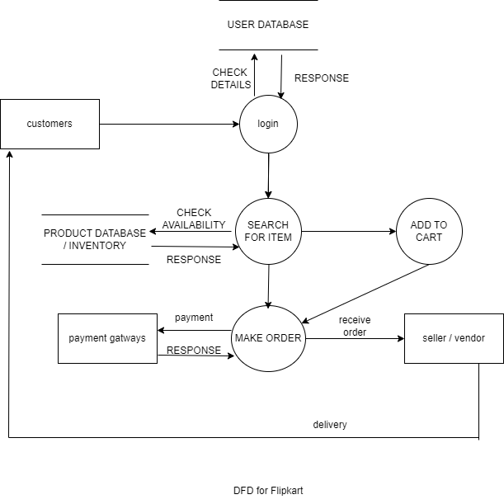

Q 5> What is Flowchart ? Create a flowchart to make addition of two numbers.

Ans. **Flow chart :**

A flow chart is a graphical or symbolic representation of process or program.

**Flow chart for addition of two numbers :**

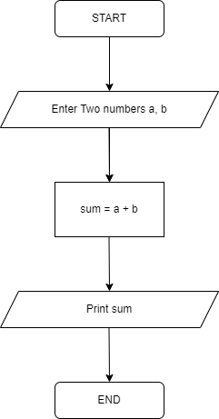

Q 6> What is Use Case Diagram ? Create a use case on bill payment on paytm.

Ans. **Use case diagram :**

It is a diagram which represents all the user’s interactions with a system or provides visual representation of how user interacts with system.

use case on bill payment on paytm **:**

